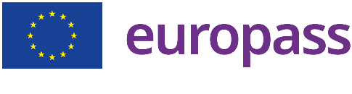
Your Name
Creative and innovative marketer with [number] years of experience developing successful marketing strategies for national and international brands. Expert in planning and executing multi-channel marketing campaigns including social media, online advertising, events and promotions.
(+33) 666666666 | Marie.dupont@gmail.com | Address: Paris, France
Birthday: 17/12/1995 | Nationality: French | Gender: Male

Professional experience
Marketing Manager, [company name], [city], [country]
January [start year] - ongoing
- Development and implementation of the company's marketing strategy
- Management of multi-channel marketing campaigns
- Analysis of marketing data to assess the effectiveness of campaigns
- Collaboration with cross-functional teams

Digital Marketing Executive, [company name], [city], [country]
May [start year] - December [end year]
- Planning and implementing digital advertising campaigns to increase company visibility and sales
- Analysis of the performance of advertising campaigns to optimize conversion rates and costs
- Management of the company's website to ensure optimal user experience and high conversion rates

Marketing Intern, [company name], [city], [country]
September [start year] - December [end year]
- Support the marketing team in the planning and execution of advertising campaigns
- Creation of marketing content for social media, email and website
- Analysis of marketing data to assess campaign results and identify opportunities

Education
Master in Marketing, [university name], [city], [country]
September [start year] - June [end year]
Research project on the impact of online advertising on consumer buying behavior
BA in Marketing, [university name], [city], [country]

©AZURIUS – Modeles-de-cv,com
September [start year] - June [end year]

Languages

English (Level C2)
French mother language)

Skills

- Microsoft office
- Google Analytics, Google AdWords, Facebook Ads
- Trello, Asana, Slack

Interpersonal skills

- Skills 1
- Skills 2
- Skills 3
- Skills 4

Hobbies and interests

- Passionate about traveling and discovering new cultures. I have visited over 15 different countries and enjoy exploring new places to broaden my horizons.
- Passionate about reading, especially books on business, psychology, personal development and travel

